Differences

IN vs. EXISTS

The main difference between them is that IN selects a list of matching values, whereas EXISTS returns the Boolean value TRUE or FALSE.

IN Operator
The IN operator is used to retrieves results when the specified value matches any value in a set of values or is returned by a subquery.
This operator allows us to specify multiple values along with the WHERE clause.
It reduces the use of multiple OR conditions in SELECT, INSERT, UPDATE, and DELETE queries; that's why it is also called the shorthand for multiple OR conditions.
In this operator, the inner query executes first, and the result obtained is used by the outer query to display the output.
It should be remembered that the inner query is executed only once.
Syntax:
SELECT column_name(s) FROM table_name
WHERE column_name IN (value1, value2, - - - - );

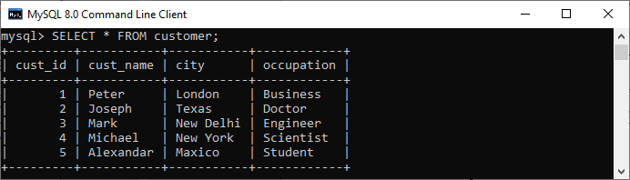

If we want to get all customer details whose occupation is either doctor, engineer, or scientist, then we can use the statement as follows:
SELECT * FROM customer WHERE occupation IN ('Doctor', 'Scientist', 'Engineer');
Output:
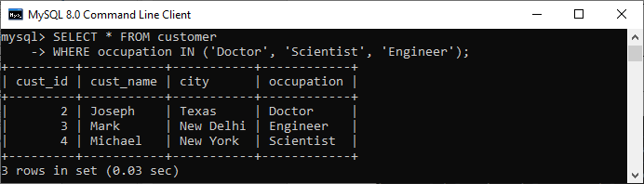

EXISTS Operator:
EXISTS is a Boolean operator which checks the subquery result and returns an either TRUE or FALSE value.
It is used in combination with subquery and checks whether a row is returned through this subquery or not.
This operator returns TRUE if the subquery returns single or multiple records. Otherwise, it gives a FALSE result when no records are returned.
We can use the EXISTS operator with SELECT, UPDATE, DELETE, and INSERT statements.
Syntax:
SELECT col_names FROM tab_name WHERE [NOT] EXISTS (SELECT col_names FROM tab_name WHERE condition);

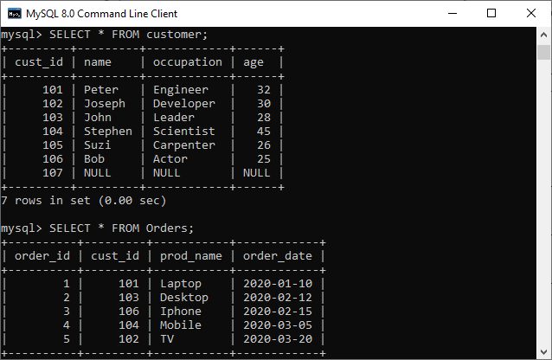

EG:

SELECT name, occupation FROM customer WHERE EXISTS (SELECT * FROM Orders WHERE customer.cust_id = Orders.cust_id);
Output:

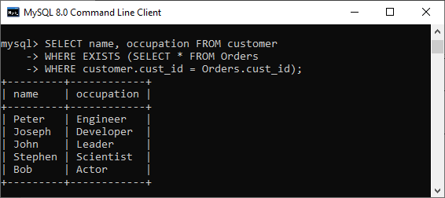

SN | IN Operator | EXISTS Operator
1. | It is used to minimize the multiple OR conditions. | It is used to check the existence of data in a subquery. In other words, it determines whether the value will be returned or not.
2. | It compares the values between subquery (child query) and parent query. | It does not compare the values between subquery and parent query.
3. | It scans all values inside the IN block. | It stops for further execution once the single positive condition is met.
4. | It can return TRUE, FALSE, or NULL. Hence, we can use it to compare NULL values. | It returns either TRUE or FALSE. Hence, we cannot use it to compare NULL values.
5. | We can use it on subqueries as well as with values. | We can use it only on subqueries.
6. | It executes faster when the subquery result is less. | It executes faster when the subquery result is large. It is more efficient than IN because it processes Boolean values rather than values itself.
7. | Syntax to use IN clause:  SELECT col_names  FROM tab_name  WHERE col_name IN (subquery); | Syntax to use EXISTS clause:  SELECT col_names  FROM tab_name  WHERE [NOT] EXISTS (subquery);

Group BY and Order BY:
SN | GROUP BY | ORDER BY
1. | It is used to group the rows that have the same values. | It sorts the result set either in ascending or descending order.
2. | It may be allowed in CREATE VIEW statement. | It is not allowed in CREATE VIEW statement
3. | It controls the presentation of rows. | It controls the presentation of columns.
4. | The attribute cannot be under aggregate function under GROUP BY statement. | The attribute can be under aggregate function under ORDER BY statement.
5. | It is always used before the ORDER BY clause in the SELECT statement. | It is always used after the GROUP BY clause in the SELECT statement.
6. | It is mandatory to use aggregate functions in the GROUP BY. | It's not mandatory to use aggregate functions in the ORDER BY.
7. | Here, the grouping is done based on the similarity among the row's attribute values. | Here, the result-set is sorted based on the column's attribute values, either ascending or descending order.

WHERE vs. HAVING :
The following comparison chart explains their main differences in a quick manner:
Comparison Basis | WHERE Clause | HAVING Clause
Definition | It is used to perform filtration on individual rows. | It is used to perform filtration on groups.
Basic | It is implemented in row operations. | It is implemented in column operations.
Data fetching | The WHERE clause fetches the specific data from particular rows based on the specified condition | The HAVING clause first fetches the complete data. It then separates them according to the given condition.
Aggregate Functions | The WHERE clause does not allow to work with aggregate functions. | The HAVING clause can work with aggregate functions.
Act as | The WHERE clause acts as a pre-filter. | The HAVING clause acts as a post-filter.
Used with | We can use the WHERE clause with the SELECT, UPDATE, and DELETE statements. | The HAVING clause can only use with the SELECT statement.
GROUP BY | The GROUP BY clause comes after the WHERE clause. | The GROUP BY clause comes before the HAVING clause.

Select * from user_table —available default tables in DB.

